Networks / PCA / connectedness: EURUSD and AUDUSD
Method 28 / pair slice of eight-major system / Alpari D1 full available history

Study setup
Logical pair: EURUSD , AUDUSD
Broker symbols: EURUSD_i , AUDUSD_i
Snapshot: 2026-11-03_majors_alpari_D1
Timeframe: D1
Matched return window: 1999-01-05 to 2026-11-02 (UTC bar dates)
Matched return count n: 7201
System panel n: 7127
Dropped unfinished last bar dated 2026-11-03 UTC after a tick-volume check against the prior complete day.
VAR lag (BIC): 1; GFEVD horizon H=10
System TCI: 54.0425
Complete matched rows (Excel): EURUSD-AUDUSD_Network_D1.xlsx

Method carried forward
Three system-level tools on the eight-major daily log-return panel. (1) Network distance d_ij = sqrt(2*(1-rho_ij)) from Pearson correlation. (2) PCA eigenvalues of the correlation matrix R (R v = lambda v). (3) Diebold-Yilmaz total connectedness index (TCI) from a VAR with generalised forecast-error variance decomposition (GFEVD), horizon H=10; lag order chosen by BIC with maxlags=10. TCI = 100 * sum_{i!=j} theta_tilde_ij / N after row-normalising GFEVD shares. Pair reports show d_ij, rho_ij, and the directed pair spillover shares from the system theta_tilde matrix. Edges and TCI are not trading signals.

Pair results
Pearson rho: 0.558036
Network distance d_ij: 0.940174
theta_tilde[EURUSD->AUDUSD] (row EURUSD, col AUDUSD): 0.101085
theta_tilde[AUDUSD->EURUSD] (row AUDUSD, col EURUSD): 0.108895
PCA lambda_1: 3.817794
PCA variance share PC1: 0.477224

Conclusion
For EURUSD-AUDUSD: d_ij=0.9402 from rho=0.5580. Pair spillover shares 0.1011 / 0.1089. System TCI=54.04. Not a trading signal.

Pair charts
Daily closes

Daily log returns
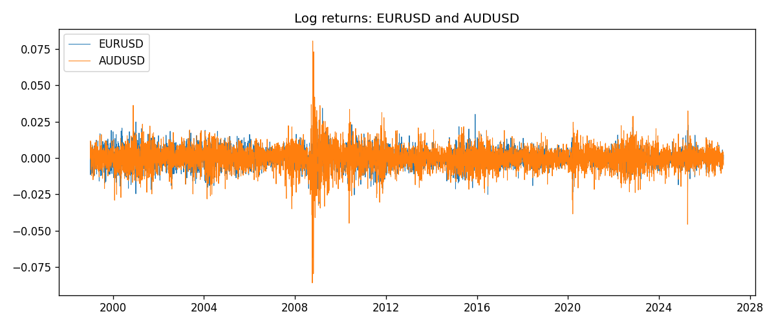

System charts (shared)
Correlation matrix

Distance matrix

PCA eigenvalues

GFEVD theta_tilde


Data report
First 15 matched rows
time | EURUSD_log_return | AUDUSD_log_return
1999-01-05 | -0.0048360507 | -0.00080418179
1999-01-06 | -0.011547966 | 0.011836351
1999-01-07 | 0.0076280636 | 0.0088650256
1999-01-08 | -0.010902799 | 0.00031515916
1999-01-11 | -0.007103287 | 0.0072213815
1999-01-12 | 0.0045103728 | -0.0048608485
1999-01-13 | 0.010845346 | -0.0078902098
1999-01-14 | 0 | -0.002696916
1999-01-15 | -0.010153245 | 0.007123101
1999-01-18 | 0.0036256946 | 0.00094592471
1999-01-19 | -0.00017235436 | 0.0072225153
1999-01-20 | -0.0031939256 | 0.0012507819
1999-01-21 | 0.0030215416 | 0.00078094498
1999-01-22 | -0.0012075213 | -0.012252745
1999-01-25 | -0.0030251979 | -0.0039591468
Last 15 matched rows
time | EURUSD_log_return | AUDUSD_log_return
2026-10-13 | 0.0037402957 | 0.0035007712
2026-10-14 | -0.0037582255 | -0.0015193215
2026-10-15 | 0.0056053107 | -0.0075447063
2026-10-16 | 0.0017724895 | 0.0033906408
2026-10-19 | -0.0025394633 | 0.0050859986
2026-10-20 | 0.0023881672 | 0.0034620426
2026-10-21 | -0.00032046717 | 0.0036066384
2026-10-22 | -0.0015949606 | -0.0012672558
2026-10-23 | -0.001338521 | 0.0023765656
2026-10-26 | -0.0022706559 | -0.0032032829
2026-10-27 | -0.004152342 | 0.0016669876
2026-10-28 | 0.0022262927 | 0.0040915541
2026-10-29 | 0.0022571351 | -0.0040915541
2026-10-30 | -0.0011458446 | 0.0010102376
2026-11-02 | 0.002120569 | -0.0049184984

